Restoration of WASP (W.A Supercharged Peugeot).
Under taken by Brian Eyre

Started November 02 / 2019
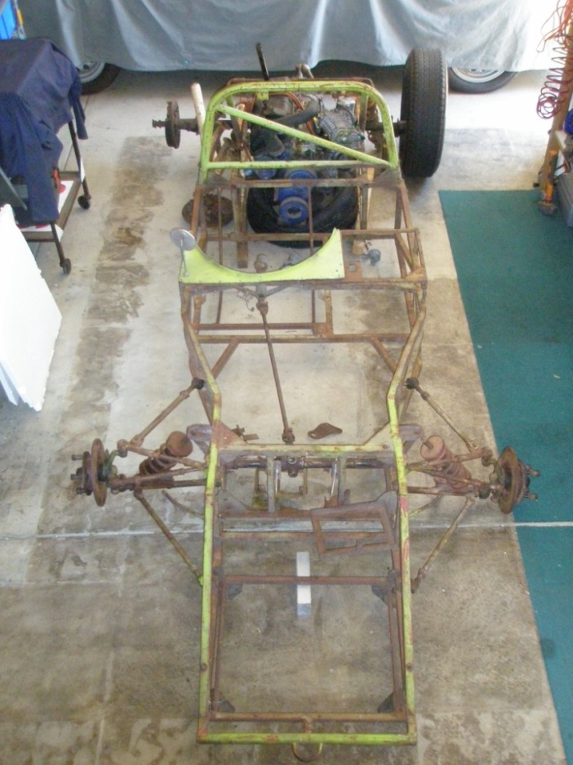
Original El Toro “sports car” chassis as last used in 1987 (and found in 2000)
(Motor, gearbox, front brakes not representative)

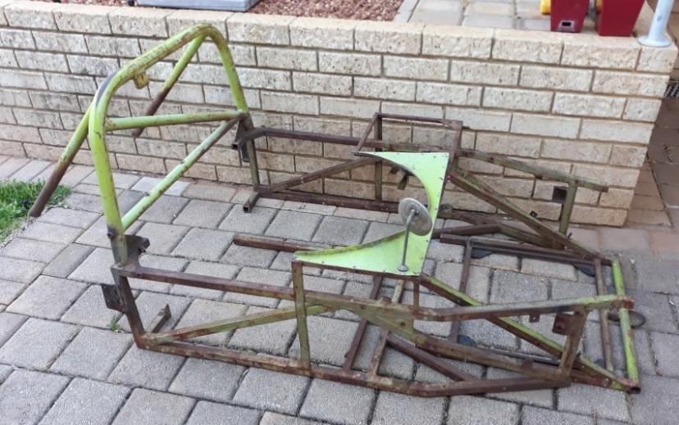
Sports car configuration drivers bay, side pods frame and front wedge as removed late 2019

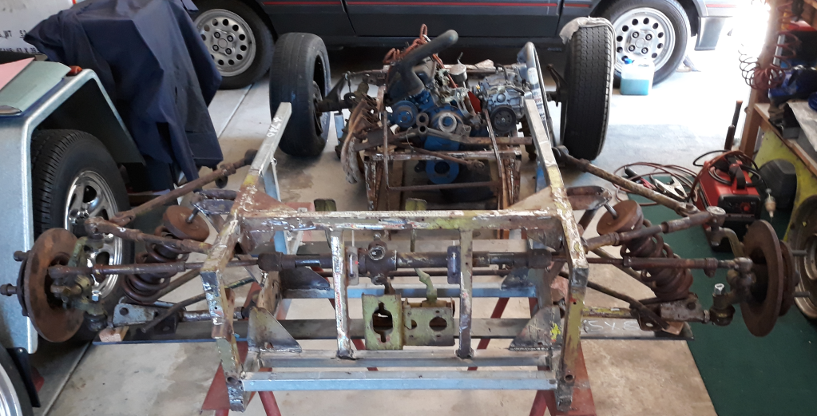
Original chassis front end repair with all rusted and bent components renewed. (from front)
(Front suspension pick up points reverted to original position and brakes restored to WASP 1960 specs)

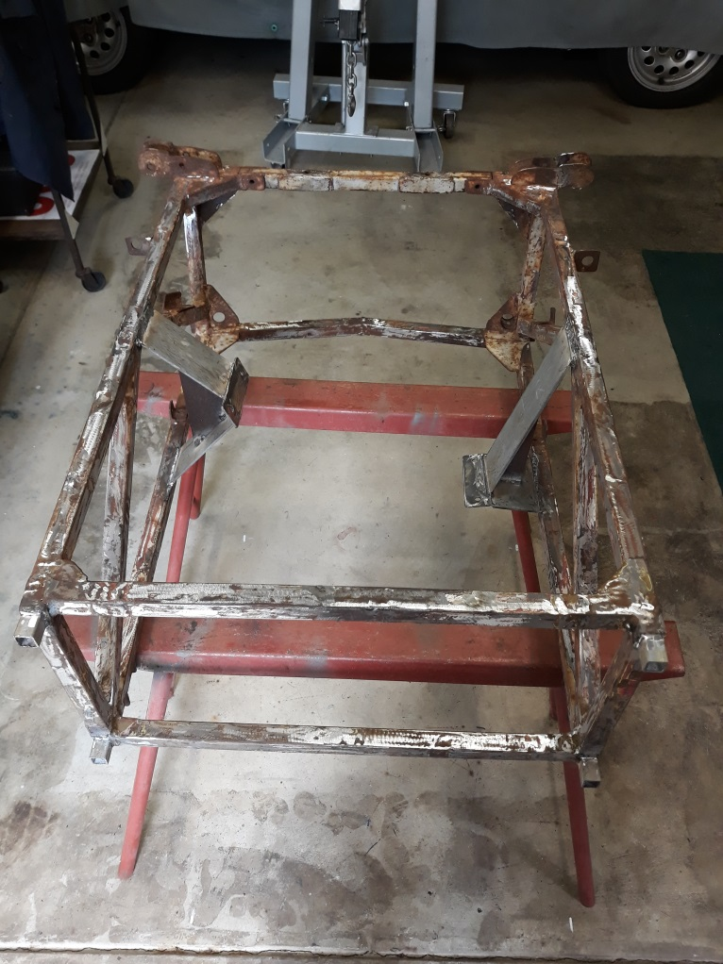
Original chassis rear end repair / clean up. (from front)
(New Peugeot engine mounts and rear suspension mount points reverted to 1960 specs)

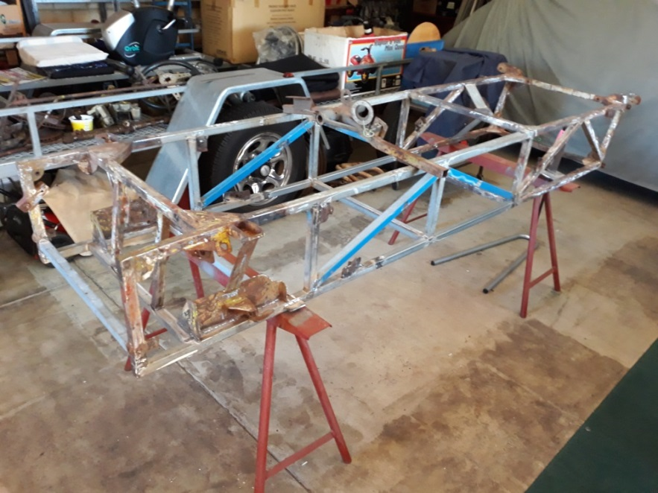
Rebuilt and complete chassis to 1960 specifications and historic photos.
(New middle chassis components and incorporating restored original front and rear end).

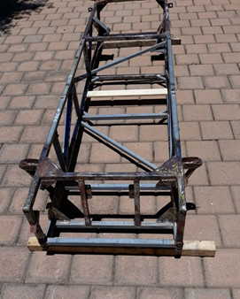

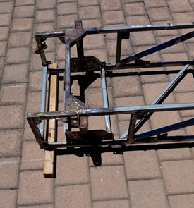
Front view of rebuilt chassis showing front end rebuild incorporated.

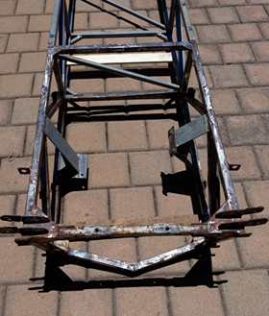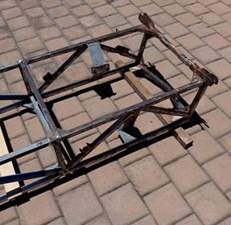

Rear view of rebuilt chassis showing incorporated re built rear end

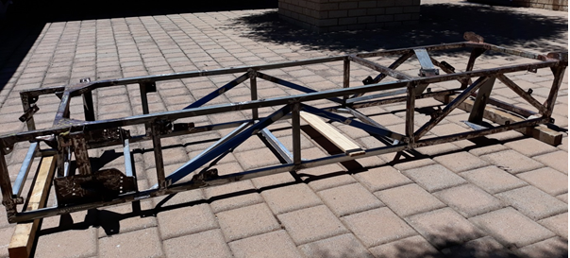
Re built WASP chassis ready for blast and paint Jan 2020

Chassis Notes:
New top and bottom side rails in driver space, new cross pieces with diagonals as per original plan.
Wheelbase restored back to original 84 inches.
Front and rear wheel track back to original specs.

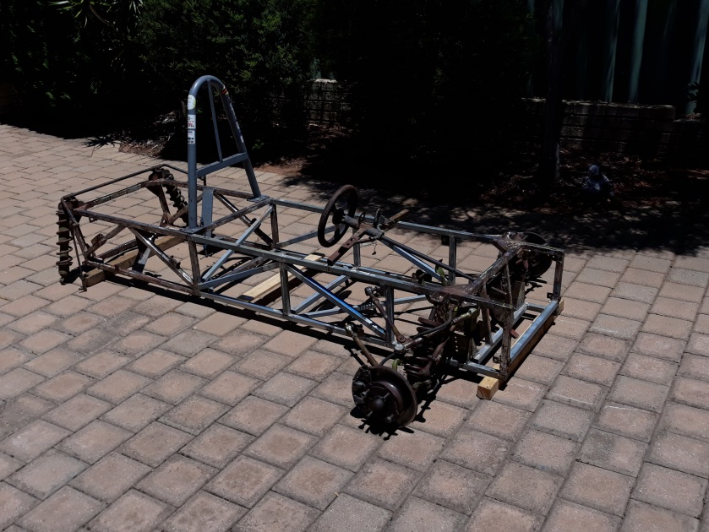

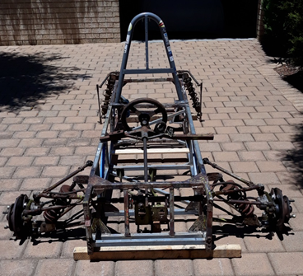
Rebuilt chassis from front showing all original parts dummy fitted Feb 2020

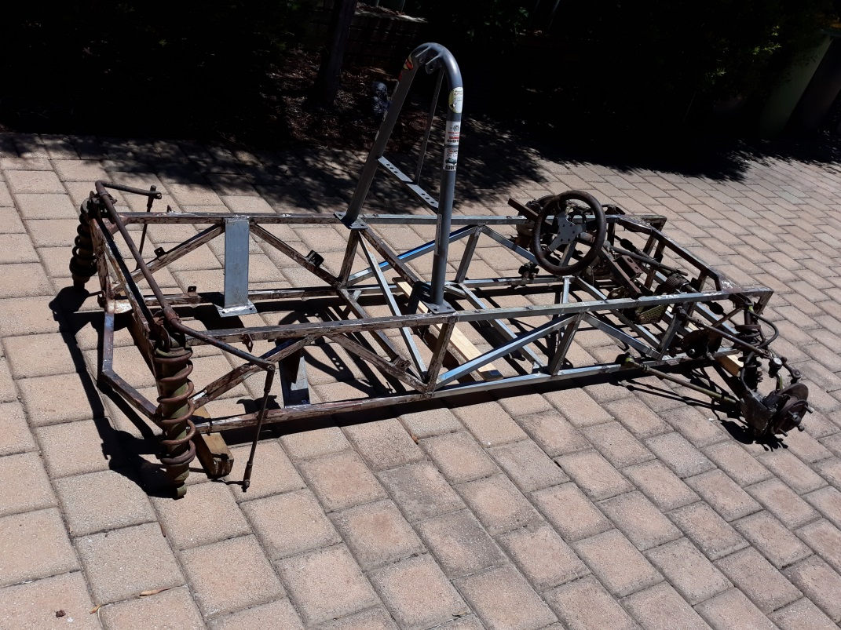

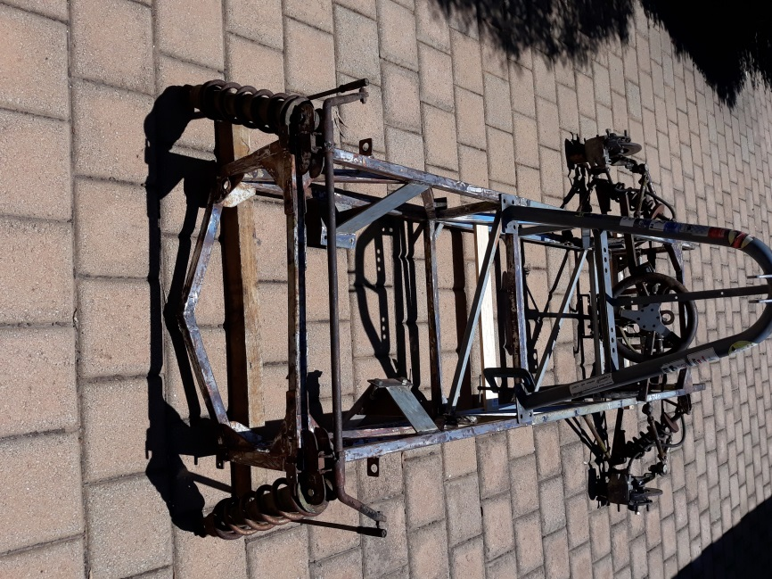
Rebuilt chassis from rear showing all original parts dummy fitted

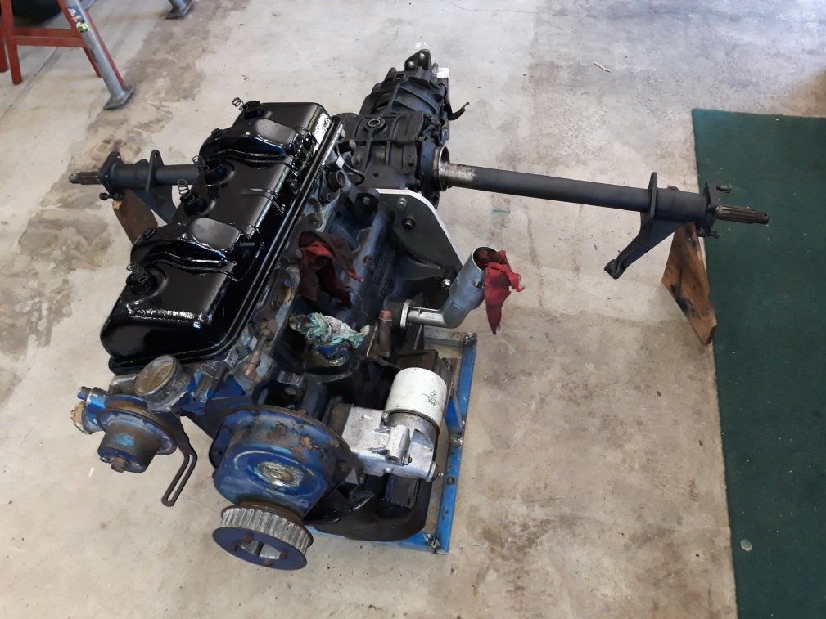
Rebuilt and modified Peugeot 1600cc engine (period)

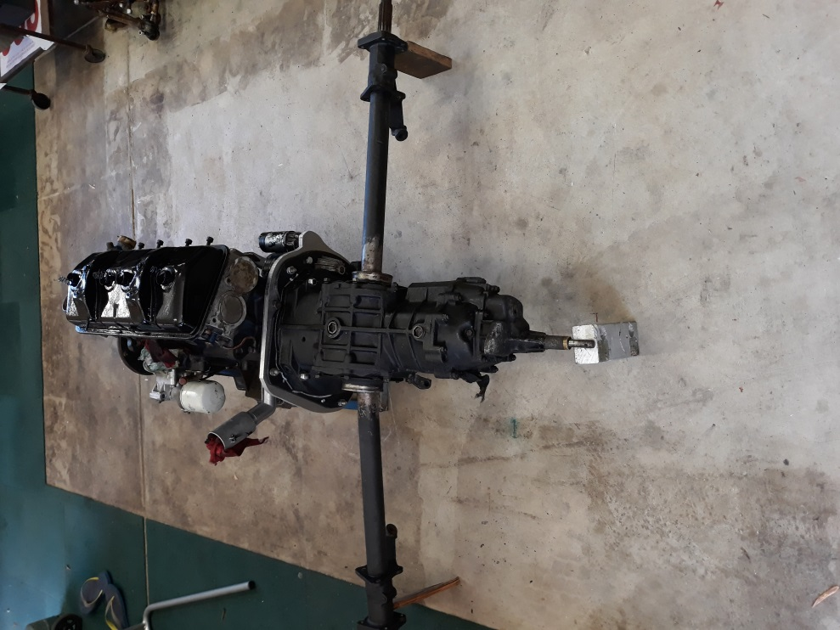
VW swing axle gearbox ready to fit (period)

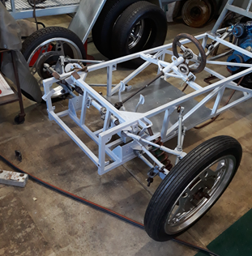
Rebuilt / primed chassis with front end parts re fitted

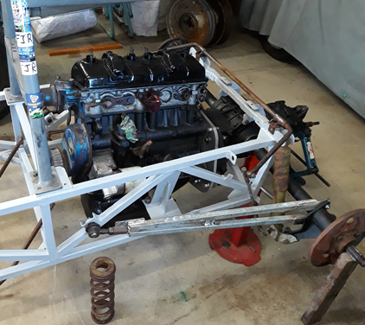
Rebuilt / primed chassis and parts fit up rear end

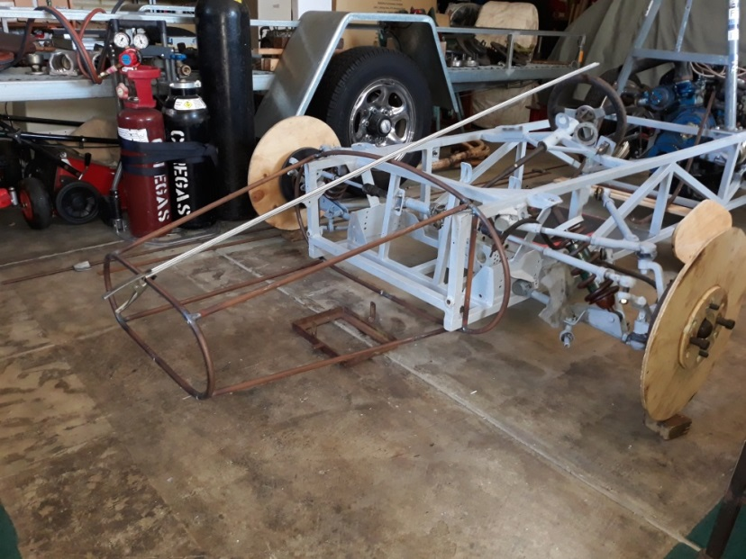
New draft nose piece draft April 2020

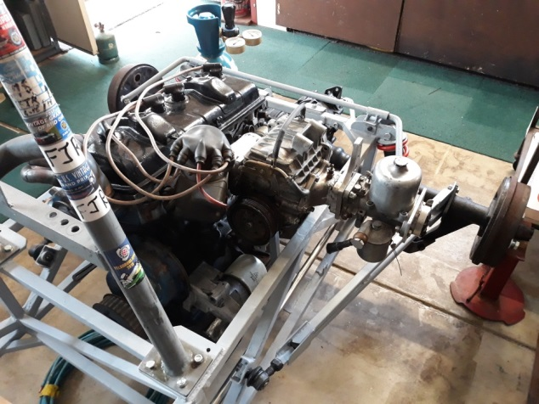
Magneto, supercharger, trial fit up April 2020

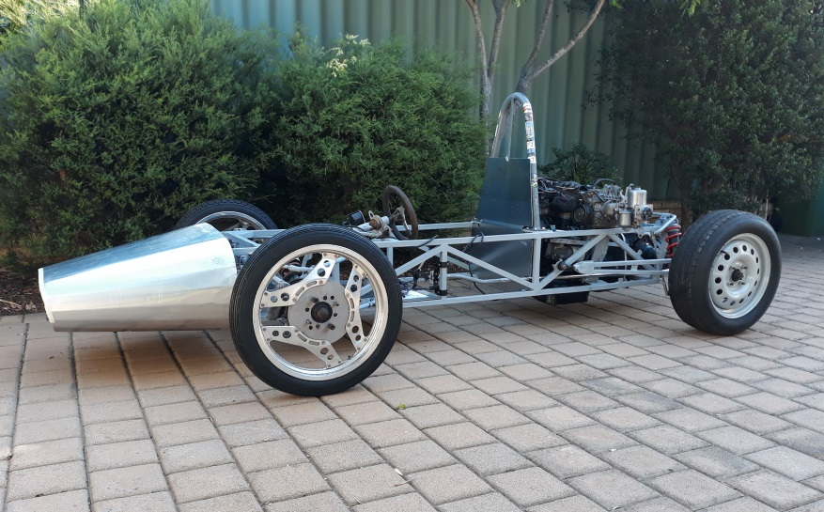
Finally a roller, with temporary front wheels. May 2020

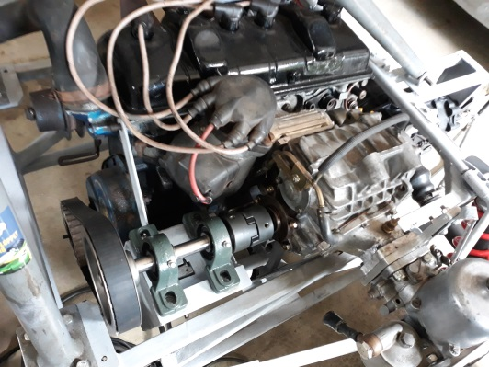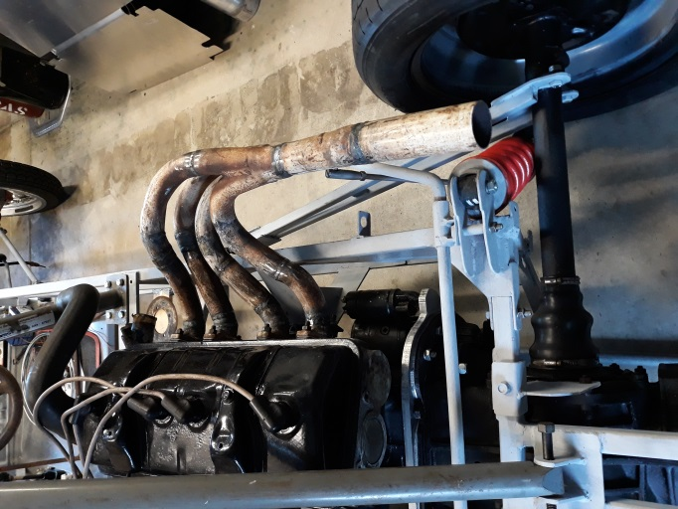
New Supercharger drive , new exhaust headers. June 2020

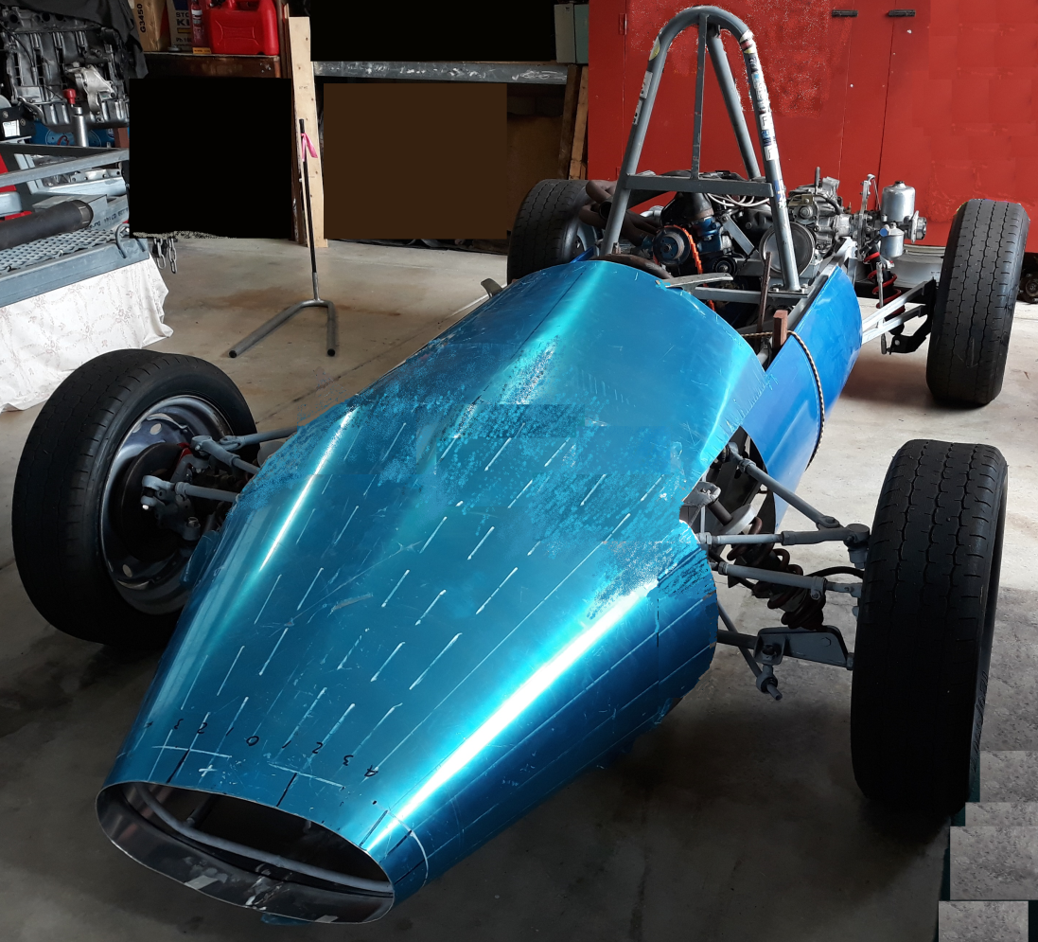
Mock up of final body with correct wheels July 2012

